Library of Congress, Chronicling America, **Clarke Courier, issue of Wednesday, July 11, 1900**

<https://chroniclingamerica.loc.gov/lccn/sn85025371/1900-07-11/ed-1/seq-2/>

Page 2, fifth column to right, **editorial by John Crown on the** **purpose and meaning of the Confederate monument to be dedicated in Berryville** on July 21, 1900:

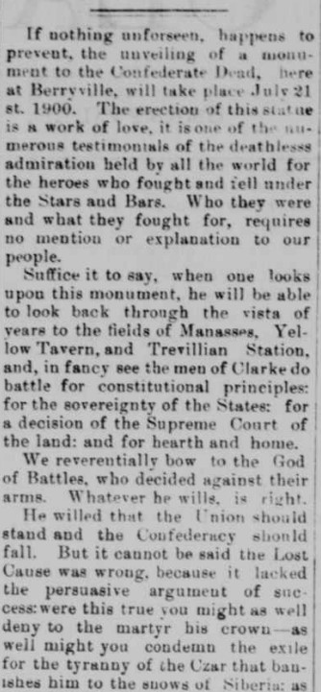

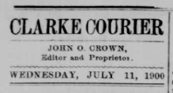

“… decision of the Supreme Court of the land” refers to

*Dred Scott v. Sandford*, 1857, holding that negroes are . *. . “beings of an inferior order” . . . and that they have no rights which the white man was bound to respect; and that the negro might justly and lawfully be reduced to slavery for his benefit.”* and therefore could not be

considered citizens nor entitled to any such rights.

Reversed by the 13th, 14th, and 15th Amendments to

the US Constitution, following the defeat of the Confederate States of America.

